CREATING mak EMAIL ACCOUNT IN EUDORA
1. Launch Eudora from your desktop
2. Go to "Tools" then Click "Personalities"
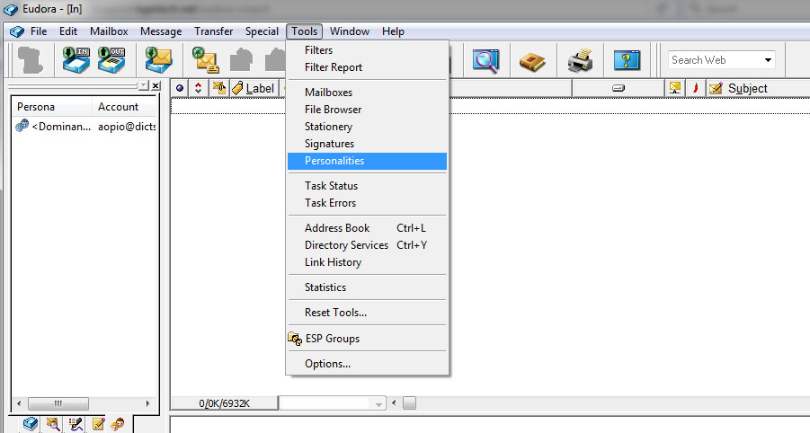
3. Right Click on "Persona" then Click "New" A new account wizard window will pop out
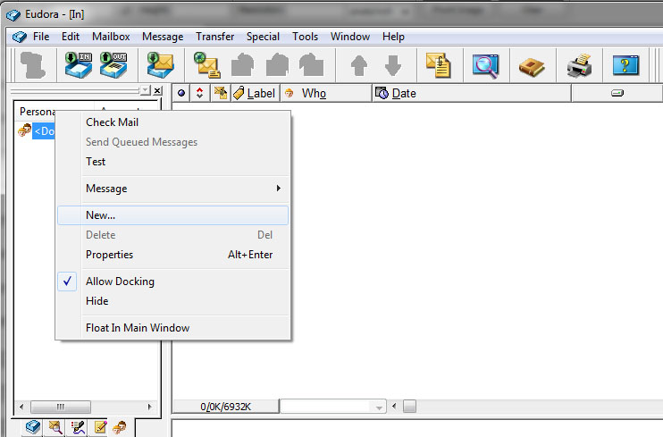

Account wizard window for setting up mail
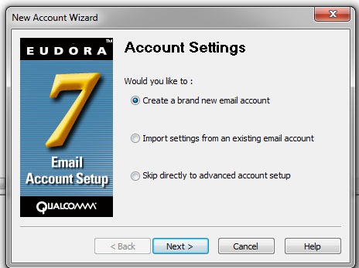
4. Click "Next" Write your personality name and then Click "Next"
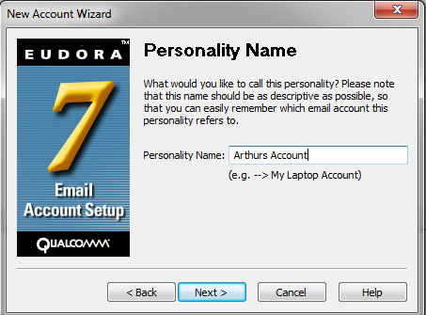

5. In the Personal Information window write your full Name and Click "Next"
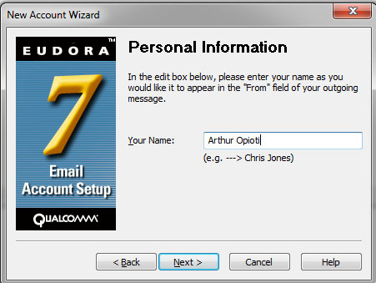
6. In the Email Address window - Type your email address e.g "yourname@dicts.mak.ac.ug" and then Click "Next"
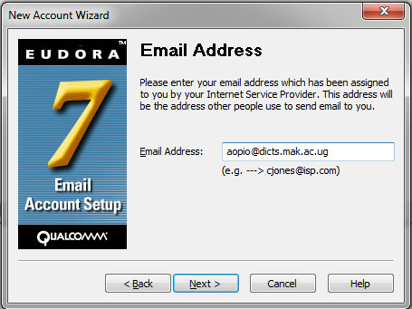
7. After typing your email address, Click "Next" and the "UserName" window pops up, make sure that your username is the full email address instead of just the initials

8. In the "Incoming Mail Server" window type "mail.mak.ac.ug" as the "Incoming Server" and make sure the "Test Server" Check-box is checked and that radio "POP" is also checked and then Click "Next"
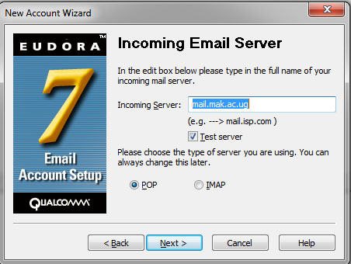
9. For the "Outgoing Mail Server setting", the Check-box "Test server" must be checked and "Allow Authentication" must be checked as well the Click "Next"
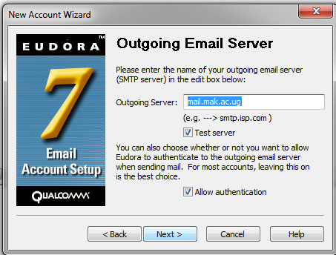
10. After configuration is done, a window showing "SUCCESS" is displayed - in a short while you should be able to send and receive mail

VERIFYING CONFIGURATION
11. To verify configuration and to see whether your able to send and receive mail
Go to "Tools" and then Click "Options"
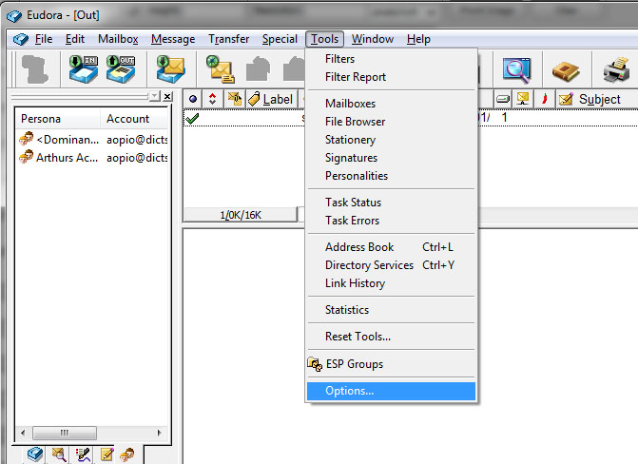
12. With the "Options" window showing, verify that everything is rightly written Click the "Getting Started" Icon, and verify "Incoming and Outgoing server" are correctly typed and that the "Allow Authentication Checkbox" is checked
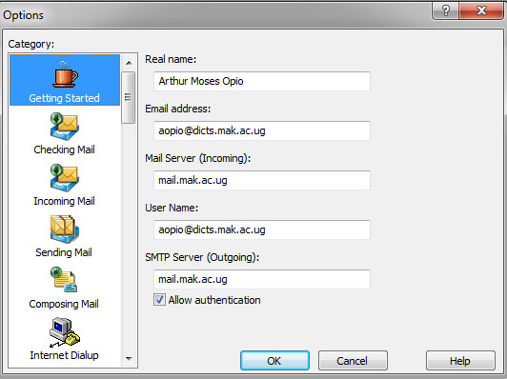
14. Click the "Checking Mail" Icon and verify everything and make sure the "Send on Check" checkbox is checked and that the "Secure Sockets when Receiving" drop box is set to "Required, STARTTLS"
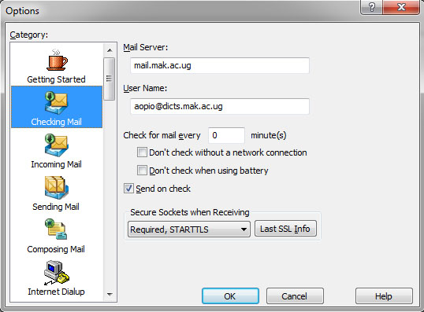
13. Click the "Incoming Mail" Icon and make sure the radio button "server configuration" is checked to be "POP" and "Authentication Style" checked to "passwords"
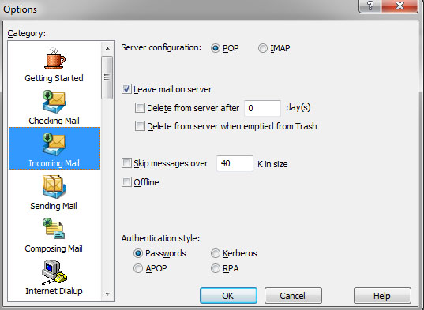

14. Click the "Sending Mail" Icon and make sure the "SMTP Relay Personality" is set to your account like "Arthurs Account" as shown in the picture, Make sure all the four check boxes "Allow Authentication", "Immediate Send", "Send on Check", "Use submission port (587)" is checked and the rest remain as is.
