Student Tutorial on Accessing and Using MUELE – March 2014
Tutorial Overview
This tutorial aims to guide the new student user at Makerere University in accessing and using MUELE for the best e-Learning eXperience.
MUELE is an abbreviation for Makerere University E-Learning Environment, the University’s official Learning Management System (LMS), customized from the Moodle Open Source software.
As of March 2014, there are over 40,000 users in MUELE with valid login accounts and we are glad that you are a part of this online teaching and learning fraternity that has grown over a period of five years since 2009 when MUELE was setup, having transitioned from the proprietary/licensed Blackboard LMS.
MUELE is therefore a ‘place’ where interested lecturers upload and/or create course materials (which may include but are not limited to course files, discussion forums, quizzes, assignments, wikis, course information and updates, and much more as may be relevant to each tutor/lecturer).
The students’ role is to make an effort to access the course materials and participate in any activities created or made available by the tutors, as well as to find new information to enhance their learning.
As the years go by and technologies advance, administrators, teachers and students alike are now challenged to think of new ways to create knowledge, interact with it or make information available. One of those ways is the use of mobile devices like phones, ipads, PDAs among others. It is time to think about mobile learning affordances or possibilities!
Tutorial Objectives
At the end of this tutorial the student should:
- Have a better understanding of eLearning
- Know and practice the skills necessary for successful eLearning
- Be able to effectively access their courses in MUELE
- Take a practical online test on learning styles so as to understand their learning abilities better and improve on their overall education experience at Makerere University.
Tutorial coverage
This tutorial covers the following areas:
- Overview of MUELE at Makerere University
- Definitions of Learning Management systems and eLearning
- Skills for successful eLearning
- Using MUELE (advantages, creating accounts, editing profiles, accessing courses)
- Learning styles questionnaire
Key Words
A Learning Management System (or LMS) is a software package that enables the management and delivery of electronic learning content and resources to students.
e-Learning refers to the use of electronic media and information and communication technologies to enhance teaching and learning. This may involve the use of computers, CD-ROMs, Internet and the web-based resources and other media for delivery and access of learning materials. Sometimes the term eLearning may be used interchangeably with online learning, although online, may tend more toward learning with the assistance of the internet. Makerere University currently offers a blended teaching approach on some of its programmes which make use of both eLearning and face-to-face session delivery.

Skills for effective eLearning
To be a successful eLearner a student may need the following skills:
- Personal skills for active learning which involve taking responsibility for your own learning, being highly motivated with your studies and self-discipline.
- Literacy skills in reading and writing which a keen student can develop or seek support for from colleagues and other means.
- Study skills like time management, motivation, effective and timely communication, being clear of expectations and exam preparation.
- General computer skills even at a basic level of proficiency in applications like word processing, file management, saving and printing.
- Internet skills like the ability to go to web addresses or URLs, saving and printing web pages and web searching.
- Collaboration with other students and your lecturers through online discussion forums, study groups, email and other social media which enhances active learning and knowledge creation and dissemination. (Source: Charles Sturt University)
Why might I use MUELE?
- Easy access of course materials, anywhere, anytime as long you have an internet connection
- Collaboration with other students and your tutors through participation in any discussion forums on selected topics
- Sharing any interesting course related information with other students outside the classroom setting
- Review of previous information available on the LMS
- Use of chatrooms and Messaging services on the LMS
- Turn in given assignments to the lecturer via LMS
- Easily take any online tests/quizzes given by the lecturer
- View grades for any online tests or assignments you have taken
How do I get started with MUELE?
Before you can log in to MUELE you need a user account or account details (Username and Password) that give you valid access into the LMS. You create a user account on the MUELE interface by completing the Account Creation Form. You need to have a valid/working email address to include in the form. It is to this email address that the MUELE system automatically sends a message with an activation link, to get you started in accessing the LMS. Please note: Your email address is different than your MUELE account and MUELE does not generate email addresses. Please ensure that you have a valid email address first from the free and other available services like yahoo, gmail, mak webmail, among others before you embark on creating a user account in MUELE!
Creating a user account in MUELE
- In a web browser (e.g. Firefox, Internet explorer, Chrome), go to: http://muele.mak.ac.ug
The screen below appears when you open the above MUELE site
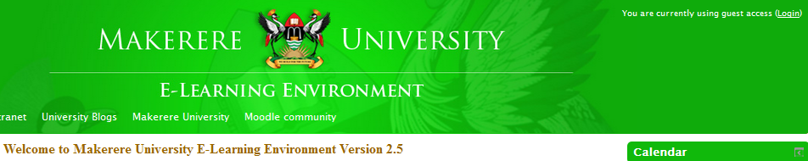
- Click on the login button on the top right indicated with an arrow in the above image. Clicking the login button brings up both the login section (which enables the user to access MUELE with valid username and password), as well as the screen below for new account creation.
- From the page that appears, click on the ‘Create new account’ link
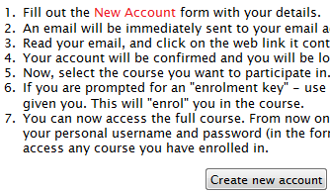
- Fill the form below with the relevant details requested and click‘create my new account’ at its bottom to submit the form for processing.
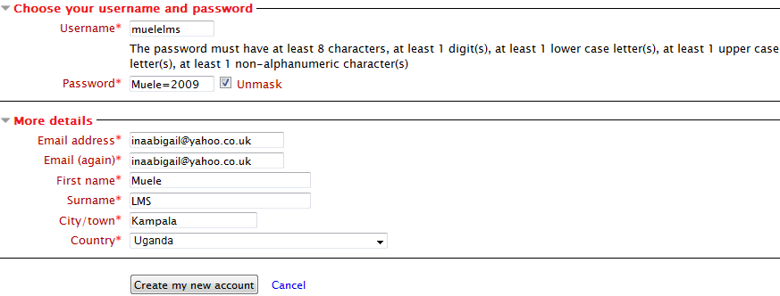
Your username is any combination of your names that you should be able to remember
The password should not be less than eight characters and should follow the given guiding criteria. For example the password in the form above has M in capital, the rest are lowercase or small letters, 2009 are digits and = is a non-alphanumeric character (others are +, @, %, & e.t.c.). Please be sure to take good note of the username and password you use to avoid forgetting them when you most need them.
The system will warn you if the username you are trying to create is already taken up by another user. In such a case, make the necessary adjustments to your username, submit the form so that you proceed to the next stage of registration.
- In the page that appears next, there will be instructions for you to go to your email address, read the instructions therein, and click on the activation link provided. Click the continue button on this page before proceeding to your email.
Logging in to MUELE
In the login page (described earlier in this document), enter your username and password that you used when creating the account (remember the password settings). Click login when done. Check the top right corner of the page after logging in and if you see your names displayed, then hooray, you have successfully logged in. Always remember to logout whenever you are done working in MUELE.
Your profile
Your profile is your identity on MUELE. The first and last name and picture listed in your profilewill identify you throughout MUELE. Other MUELE users in your courses can view your profile if they choose to.
Editing your profile
To view your profile, click on your name next to the Logout link at the top of the screen, oranywhere else that your name appears in Moodle. To edit your profile, locate the My Profile settings section within the screen and click the Edit profile link in the Settings block. A page with your details will appear. Use it to change or add whatever is necessary as well as to add your picture if you wish.
● User Picture: You can change your user icon with the “User Picture” field by browsing
for a picture.
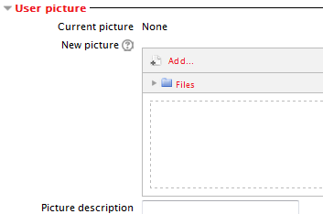
Click the User Picture link first to display the image above, then click Add to select your picture and upload it into your profile.
● The Other fieldssection has fields for various ways other users might want to contact you,
including mobile phone. Make sure to change your gender here (Female or Male) otherwise it is usually Female by default.
Accessing your MUELE course pages
Once you are logged into MUELE, you now need to enroll yourself into the courses you want to access that have been made available by your tutor/s. To achieve this goal, you need to systematically follow the access route as follows:
- Locate the name of your college from the college list in MUELE and click on it. For example College of Education and External Studies.
- Find the school where the course is delivered and click on it
- Locate the department in the school that houses the course you are looking for – e.g. Elearning Unit
- Find the course you are interested in and click on it – for example Student Tutorial on Accessing and Using MUELE. If the course is open for access, you will simply find a message instructing you to enroll into the course. Clicking on the enroll button will then grant you instant access into the files for that course. In some cases, the lecturers lock their courses with passwords or access or enrollment keys for security reasons without which a new user cannot see the contents of that course. You will need to get the password or enrolment key from the respective tutor.
Navigating through MUELE
MUELE has a navigation bar acrossthe top of each page which shows you where you are in MUELE and allows you to easilynavigate back to your course page or the site home page.This is necessary especially when you have opened many pages and need to go back to a particular location.
To navigate back to your course page, click your course’s “shortname,” or course code e.g. STM-2014,code for student tutorial on accessing and using MUELE.
To navigate to the first or home page in MUELE, click the “home” link which is on the left end ofthe navigation bar.
To do!
Go to the linksprovided below to learn more about how you learn (individual learning style) as a way to improve your learning and performance!
Go to the first link below to fill out the learning styles questionnaire and submit it online so as to know your learning style. Do not forget to open the second link also given below to get a brief explanation of the results of the Learning styles test you will have just taken.
http://www.engr.ncsu.edu/learningstyles/ilsweb.html (learning styles questionnaire)
http://www4.ncsu.edu/unity/lockers/users/f/felder/public/ILSdir/styles.htm (brief explanation of results of the learning styles test)

Good luck with your academic effort and God bless you!
The eLearning Team-Makerere University, 2014

